FLAMeS – Formation of Laser Altimetry Measuring Satellites

Students:
S. Billemont, L.S. Boersma, B. Buyens, S.R. Finck, J.P. Florijn, T.C. Goossens, N.S. Oborin, A.J. Vorobiev, G.J. van der Wel and Z. Zhou

Principal tutor:
B.G.H. Gorte

Project coaches:
P.P. Sundaramoorthy
M.M. Willaert

Introduction
In February 2010 the ICESat mission ended after 7 years of measuring ice sheet mass balance, cloud and aerosol heights, as well as land topography and vegetation characteristics. To do all this, ICESat had only one instrument on board: a space based LiDAR system (Geoscience Laser Altimeter System (GLAS)), allowing for an unprecedented 3D view of the Earth’s surface and atmosphere. The laser lifetimes, however, were severely limited because of manufacturing errors in one of the laser components.

ICESat followed only one of the possible approaches for LiDAR, namely the use of a high energy laser
and a large receiver telescope. An alternative is using a high frequency, low energy laser and a single photon detector. The advantage of the latter approach is that it has a much lower mass, but it is uncertain if even a single photon per pulse reaches the receiver. One possible solution could be the use of a swarm of satellites around the emitter, each equipped with a single photon detector. The technical feasibility of this concept has not yet been proven.

The purpose of this project was to explore this last alternative, in order to fulfill a mission similar to ICESat’s: monitoring changes that take place at the surface of the Earth. With multi-angular measurements, a new dimension of information is obtained and characteristic data such as the Bidirectional Reflection Density Function (BRDF) and the slope of the terrain can be measured. This allows inferring the nature of the observed terrain, the identification of crops and correction of anisotropic effects from other space missions.

Mission Statement
The goal of this feasibility study is to demonstrate that a satellite constellation, consisting of a single emitter and several receivers, will perform superior (in terms of performance, cost and lifetime) to existing spaceborne laser altimetry systems.

Objectives
The following top level objectives were deduced or dictated:
- Cost budget must be below existing spaceborne laser altimetry systems.
- Lifetime must be above existing spaceborne laser altimetry systems.
- Performance must be better than existing spaceborne laser altimetry systems.
- Mass budget must be below or equal to existing spaceborne laser altimetry systems
- No scanner may be used.

Design Details
The final design is a constellation designed with a single emitter micro-satellite and two formations of four identical receiver nanosatellites at different initial orbit heights. The emitter satellite starts out at an altitude of 500 km together with four receiver satellites flying at 2.18º in front, behind and to the sides of the satellite. When the orbits of this constellation have decayed to about 450 km the emitter satellite is boosted up to 500 km again, where a second formation of receivers is waiting to make measurements. The initial altitude of the second formation is 525 km. This setup enables the mission to last for at least five years.

The emitter satellite has a laser with a wavelength of 473 nm, which sends out 1 mJ pulses at 5000 Hz. The receiver satellites are equipped with a Single Photon Avalanche Diode (SPAD) with an advanced optics system to be able to detect the returning photons. The instrument is pointed to an accuracy of about 0.1º by a pointing mechanism. Also the emitter satellite has one receiver, and is always nadir pointed.
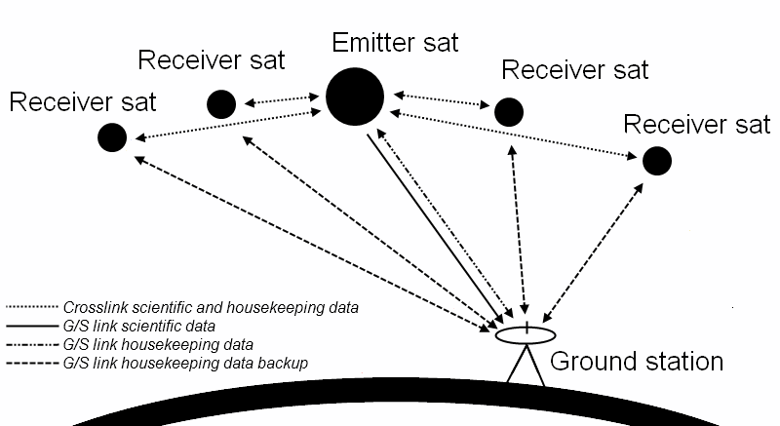
Figure 1: Communication system
The communication between the satellites is done using S-band transceivers. All data is stored on the emitter satellite until it can be sent to the ground station. For this data link an X-band transmitter is used. The attitude of the satellites is determined by sun sensors and star trackers and is controlled using a set of reaction wheels and magneto torquers. Navigation and orbit determination is done by a GPS receiver on each satellite.

Station keeping is done using a bipropellant thruster for the emitter satellite and a monopropellant thruster for the receiver satellites. In the eclipse phase the solar panels are used for relative station keeping using differential drag. Using existing Commercial Off The Shelf (COTS) technology, the total cost of the mission is calculated to be approximately 50 million dollar, about a quarter of the 200 million dollar budget of the ICESat mission.

Mission requirements and constraints
There are four key requirements for this mission. The first is that the total cost of the mission is less than that of other existing laser altimetry missions. The ICESat mission was taken as reference, which had a budget of $200 million. The same reasoning was applied to the mass and the lifetime of our mission. They also had to be equal or better than equivalent existing missions. The reference values, again taken from the ICESat mission, were 970 kg and 5 years respectively. There was one constraint and that was that no scanner was used.
From the key requirements certain requirements flowed down to the subsystems. Firstly the optical receiving payload must be pointed at the footprint of the laser pulse. This required a pointing accuracy of at least 0.1°. The designed ADCS system has an accuracy of 0.08°. From this follows the second subsystem requirement. To be able to determine the terrain height, one photon per pulse needs to be detected by the receivers. But to be able to create the BRDF at least 5 photons per pulse per receiver have to be detected. The final design receives, on average, 7 photons per pulse per receiver. This means that the correct terrain height and the BRDF can be accurately determined. To obtain these results the absolute position of the satellites needs to be known as accurately as possible. With on ground post-processing the position can be calculated to an accuracy of 1.5 mm, which is enough for our data processing. It is also necessary to know the exact time of the received pulse so all satellites need to be synchronized. To do this the GPS placed in each satellite is used to synchronize the clocks with respect to each other.

Key Requirements | Final Design
Cost has to be less than $200 million | Mission cost of $52.785 million
Lifetime has to be at least 5 years | Minimum of 5 years
Mass is less than 1000 kg | Total mass of 189.59 kg
Additional requirements
5 received photons per pulse per satellite | 7 received photons per pulse per satellite
Pointing accuracy of at least 0.1° | Final accuracy is 0.08°
Footprint size less than 100m | A 4mm beam width gives a footprint of 72m
Accurate knowledge of satellite positions | Within 1.5mm after post processing
On board clocks must be synchronized | Achieved by using GPS on each satellite
Table 14. 1: Requirements and constrains

Laser Design Concept
Satellite altimetry missions use active remote sensing techniques. For that reason the quality of the system is dependent on the emitted electromagnetic radiation and the analysis of the returned signal. To be able to select any optical emitting device, the important parameters for optimizing the altimetry results should be revised. Several problems occur if emitting radiation is chosen as the remote sensing technique.

- First of all, general electromagnetic radiation will show isotropic behavior. This results in an effective energy loss, since most of the radiation is not pointed towards the desired position. Hence, a divergence limited source would be preferable.
- As mentioned before, the wavelength is an important parameter since it will influence the photons actually reaching Earth. Since the Earth's atmosphere is transparent for wavelengths in the visible spectrum, it would be better to have an electromagnetic radiation source with a wavelength in this interval. Next to that, a regular radiation source (like the Sun) emits radiation consisting of a whole spectrum of wavelengths. The less the number of discrete wavelengths (preferable in the visible spectrum), the higher the quality of the analysis can be.
- The total work done on the photons to reach the Earth's surface, scatter and return to the receiver is generally very large. To cope with this large work, the energy of the pulses should be high.

Laser Design Options
There are many different types of lasers. The main types that are considered are listed below:
- Helium-Cadmium (He-Cd) gas laser (wavelength 441.6 nm).
- Neodymium-doped Yttrium Aluminium Garnet (Nd-YAG) solid-state laser (wavelength 473 nm).
- Argon (Ar) gas laser (wavelength 454.6 nm).

Laser Trade Off

Criteria | Weight Factor | Nd-YAG | Ar | He-Cd
Wavelength Ratio | 9 | 9 | 7 | 5
Technical Readiness Level | 6 | 8 | 8 | 10
Cost | 5 | 5 | 9 | 10
Minimum Pump Power | 8 | 6 | 7 | 7
Repetition Rate Manipulation | 7 | 10 | 2 | 2
Volume | 7 | 10 | 4 | 3
Mass | 7 | 10 | 4 | 3
Chemical Stability | 4 | 8 | 6 | 4
Thermal Control | 4 | 8 | 6 | 5
Efficiency | 8 | 7 | 1 | 7
Weighed Total |  | 532 | 338 | 359
Table 14.2: Laser trade-off
From the laser trade-off in Error: Reference source not found it is obvious the Nd-YAG laser should be chosen in this mission. Especially the active pulse manipulation, the chemical stability (directly related to the lifetime) and the mass/volume characteristics are really good. The main drawback of the Argon laser is the poor power efficiency, resulting in pump powers in the order of kilowatts. The main disadvantage of the gas lasers in general is the poor performance of pulse manipulation. However, these types of lasers are often cheaper compared to other types.

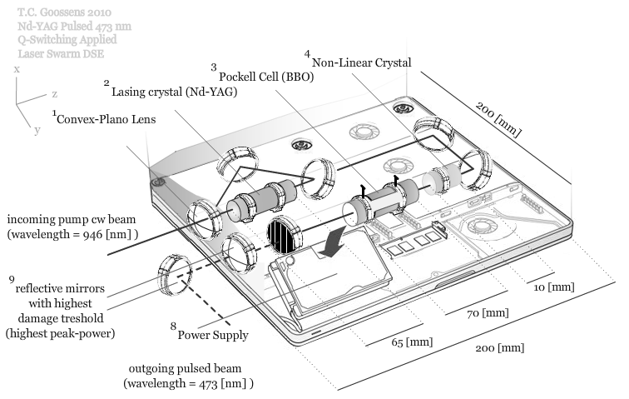
Figure 14.1: Pulsed Nd-YAG laser layout

Receiver Design Options
A number of technologies, primarily based on quantum dynamics, and devices are already in production or in development.
- Micro Photon Detector (MPD)
- Stereo Imaging Laser Altimeter (SILAT)
- Single Photon Avalanche Diode (SPAD) + micro lenses
- Single Photon Avalanche Diode (SPAD) + mirrors

Receiver Trade Off
Criteria | Weight Factor | MPD | SILAT | SPAD + micro lenses | SPAD + mirrors
Power | 7 | 6 | 6 | 9 | 9
Mass | 8 | 5 | 5 | 9 | 8
Volume | 8 | 4 | 3 | 8 | 8
Reliability | 7 | 8 | 8 | 6 | 5
Efficiency | 10 | 7 | 6 | 1 | 5
Cost | 5 | 4 | 3 | 7 | 5
Availability | 3 | 10 | 8 | 5 | 3
Lifetime | 10 | 8 | 8 | 6 | 6
Resolution | 8 | 7 | 7 | 10 | 10
FOV | 6 | 6 | 6 | 9 | 9
Weighed total |  | 462 | 433 | 495 | 504
Table 14.3: Receiver trade-off
The results of the trade-off for the receiver are shown in Table 14.3. The SPAD plus micro lenses and faceted mirror designs have much higher grades than SILAT or MPD. The SPAD with micro lenses has the lowest grade for efficiency because the lenses which are manufactured on the scale of micrometers can only increase the efficiency by factor of 5. On the other hand, the faceted mirror can increase the fill factor from 2% to 80%, which is why faceted mirror has much larger efficiency. Either SPAD design has large advantages on power consumption (100 µW), mass (tens of grams) and volume (5x5x3 mm³) comparing to either SILAT or MPD. This means the SPAD is a much more realistic and practical choice if the receiver satellites are micro- or even nanosatellites. The SPAD with faceted mirror turns out to be the best option when all aspects are considered, and it should be further investigated later on in the detailed design.

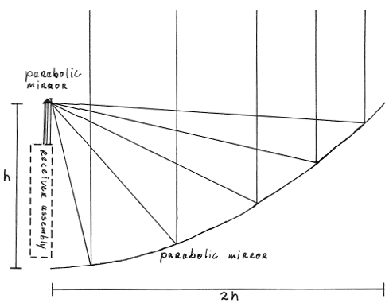
Figure 14.2: Optical system receiver

The Orbits
The emitter satellite is injected into a circular orbit (Orbit 1 on the figure 14.2) at an altitude of 500 km. The eccentricity is frozen at 0. Inclination is chosen to be 85 degrees, as this allows access to polar areas, which are places of interest for the mission. Furthermore, the inclination provides an inherent relative phase for the crossing orbits. The Right Ascension of the Ascending Node can be chosen arbitrary for the start of the mission, as no specific target is assumed for the mission. For consistency, in all following discussions it is assumed to be 0 degrees. The same goes for the Argument of Perigee and the True Anomaly. As the orbit is circular, these values are not really relevant. The emitter satellite acts as the reference for all the receiver satellites.

Unlike the emitter, the receiver satellites are placed in six different orbits and have to be designed to be able to handle all orbits and yet all the satellites have to have the same mass configuration at all times.

The orbits are divided into primary and secondary. The primary orbits are shown in figure 14.2. Receiver 1 is located in Orbit 3 which has all the same orbital characteristics of Orbit 1 with the exception of RAAN having a value of +2.18 degrees. This is the maximum angle of separation and is derived from the requirement of a laser reflection angle of 30 degrees. Receiver 2 in Orbit 2 on the other hand has a RAAN of -2.18 degrees. Both of these receiver satellites pass their ascending nodes at the same time as the emitter satellite. The reason for this is that the inclination of the orbits induces a relative phase between the satellites which is favourable for collision avoidance. Receivers 3 and 4 are placed on the same orbit as the emitter. Receiver 3 travels with a positive phase offset of 2.18 degrees in front of the emitter, while the latter is trailing the emitter with the same offset.

The final design is a constellation designed with a single emitter micro-satellite and two times a formation of four identical receiver nano-satellites at different initial orbit heights.
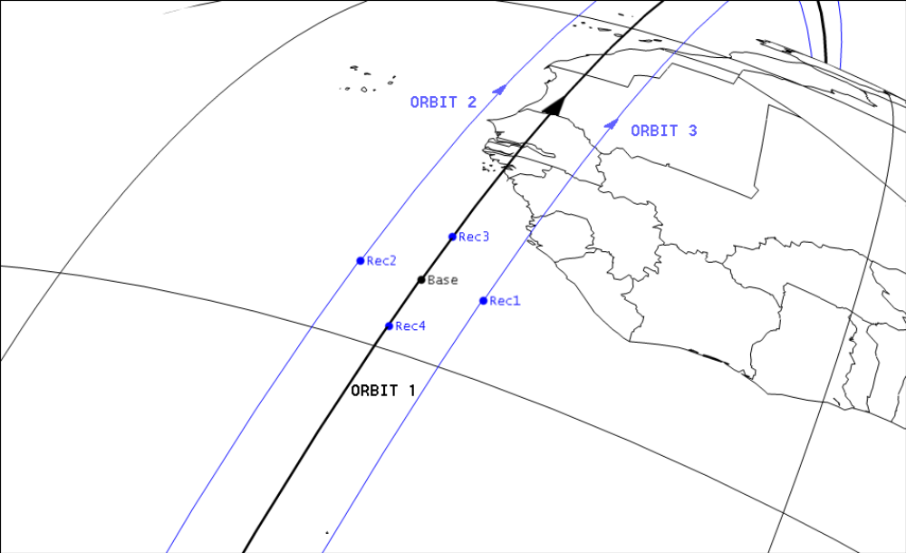
Figure 14.3: Satellites in orbit

Conclusions
The goal of this feasibility study was to demonstrate that a satellite constellation, consisting of a single emitter and several receivers, would perform superior (in terms of performance, cost and lifetime) to existing spaceborne laser altimetry systems. A LiDAR mission with a total of nine satellites is designed and dedicated to making multi-angular measurements using a low power Neodymium Yttrium Aluminum Garnet (Nd-YAG) laser, a SPAD array and advanced dedicated optics enabling intra-footprint measurements.

The emitter satellite is designed to be a micro-satellite with a total mass of just over 50 kg. All basic subsystems like ADCS, Communications and EPS are present to ensure that the payload is able to perform its mission. The payloads of the emitter satellite are the laser and one receiver. The laser is a 5000 Hz pulsed Nd-YAG laser with 1 mJ per pulse and a wavelength of 473 nm. Advanced optics is used to adapt the footprint size to optimize measurements.

All receiver satellites are identical micro-satellites with a dry mass of about 15 kg. The satellite structure is based on a six unit cubesat design, so most basic components can be bought off the shelf. The receiver instrument consists of a SPAD array with an optical system to focus as many of the incoming photons on the array as possible. A pointing mechanism and the satellite attitude are used to point the instrument to the ground target.

The satellites are inserted in six different orbital planes at two different altitudes. In the first half of the mission measurements are made by four receivers in the lower orbit, in the second half the emitter satellite is boosted up to the higher orbit, where a second set of four receiver satellites are waiting to make measurements for that part of the mission. Using this scheme less propellant is needed for orbit keeping.

A java tool has been created to simulate and validate the constellation to optimize the constellation and the laser power requirements. The mission designed is able to reach the set constraints, so the concept is considered feasible. More specifically, the simulator shows that with the systems considered it is possible to accurately determine the terrain height distribution and slopes with accuracies in the centimeter range.

Given the direct relation between multi-angular measurements and photon counts and on the other and BRDF reconstruction, it is certainly possible to determine reliably the BRDF of the terrain. However, for the exact algorithm a more detailed investigation will have to be done.

Recommendations

For further research the optics of both the emitter and receiver instruments need to be further developed and vibration tested. These parts are essential for the success of the mission and even the smallest error could render the system completely useless. For the laser, a vibration analysis for the individual components has to be performed and the lifetime has to be closely tested and investigated for every component.

Another problem which has not been treated in this research is the thermal control of the satellites. Especially in the tightly packed receiver satellites the thermal control could pose a major problem. The packing could be solved by using more state-of-the-art products or Micro Electro Mechanical Systems (MEMS).

Furthermore, to be able to boost the emitter satellite into the second formation accurate predictions of all orbits need to be made to counter the effects of precession. Further research on orbit insertion, including the proper procedure, has to be performed. Orbit modeling is also needed to determine correct separation and orbital angles. Tools for automated station keeping will also need to be developed. Also the cosine loss should be investigated in more detail to further optimize the design of the solar panels.

